TALK TITLE/POSTER TITLE
Author 1ª*, Author 2^{b}, …
ª Affiliation 1
^{b} Affiliation 2

- This document must not exceed one page (including figure and references).
- Abstract must be in English.
- Please do not change the current file format (police: Calibri 12, marge: 2.5cm everywhere, …).
- Figures have be included in the present document, as Fig. 1
- References can be included respecting the following template [1, 2].
- No supplementary data (other file or affiliation from the website form) will be taken into account.

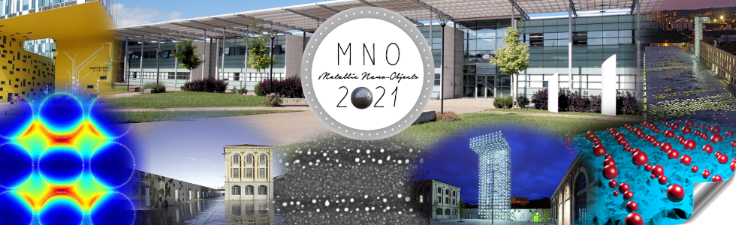
Fig. 1: legend for the current figure

References:
[1] Authors, Title, Journal, Volume, Page (Year)
[2] Authors, Title, Journal, Volume, Page (Year)

* Corresponding author: email@univ.fr

